MACH4METAL

metalworking machinery
Transito 21
6909 DA BABBERICH Netherlands
Tel. +31 (0)316-247123
Fax: +31 (0)316-247956
info@mach4metal.com
www.mach4metal.com

Bank No : 66.52.13.883
IBAN : NL33 INGB 0665 2138 83
BIC : INGBNL2A

A sym. 3 roll Plate bender
DAVI Promau 3000 x 2

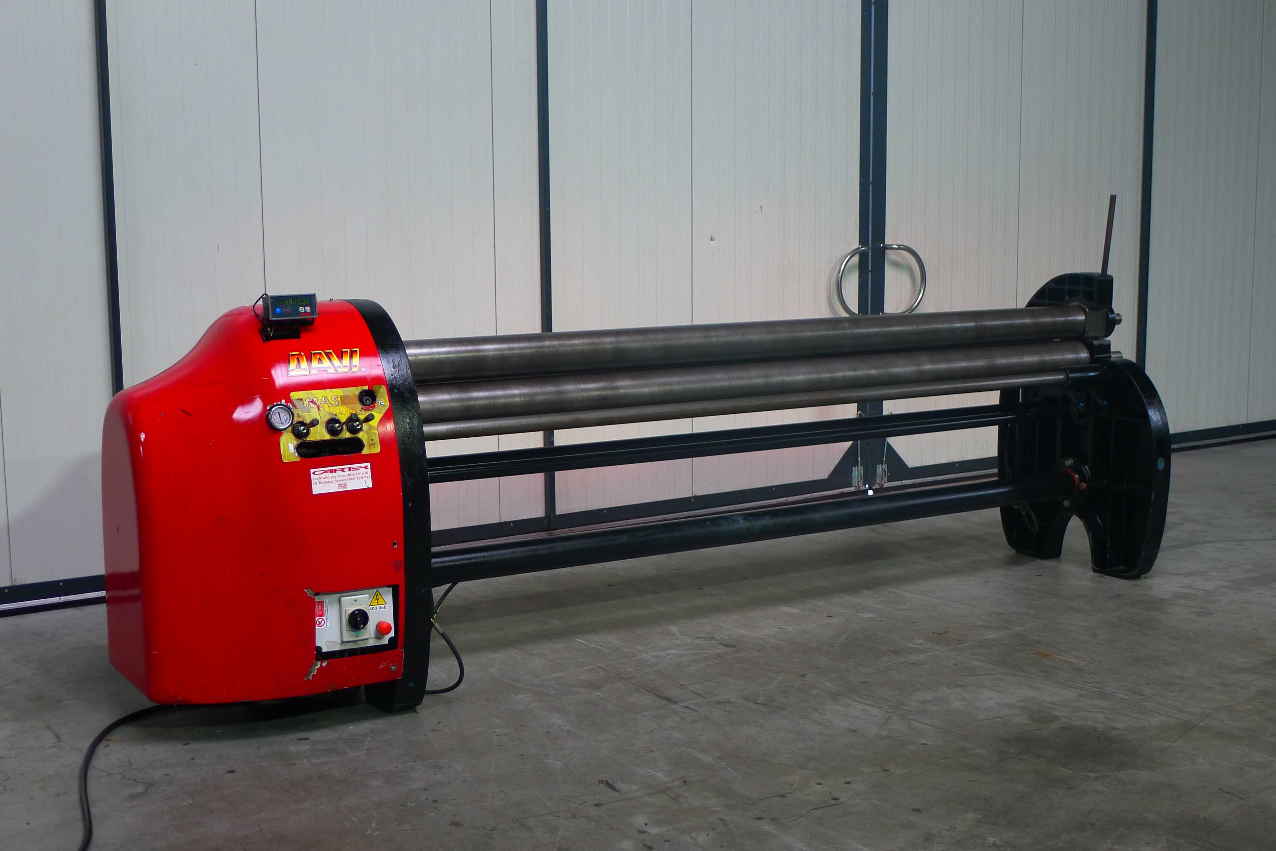
- Make : Davi Promau
- Typ : MAS 3014
- Serial : 30030052
- Age : 09/2002

- bending length : 3.000
Rolling capacity
- Pre bending : 3000 x 1.5
- Bending : 3000 x 2.0
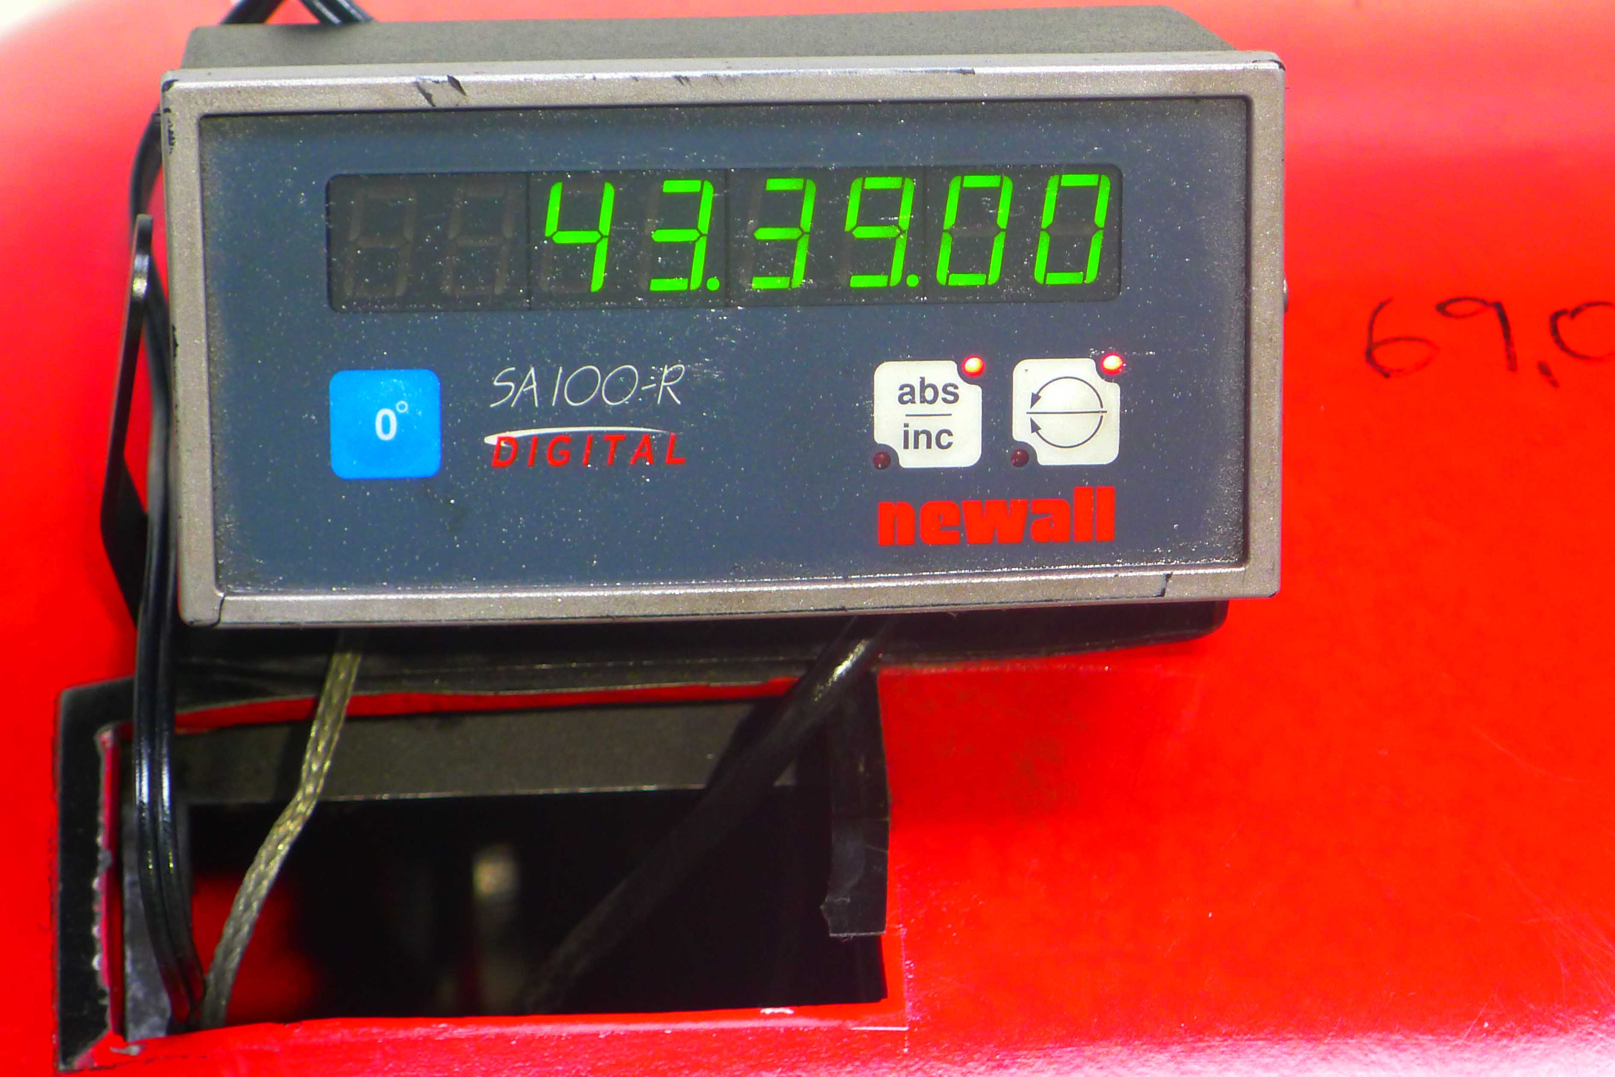
- Roll Diam Ø : 140 mm

- Dimensions
- Length : +/-4.000
- Width : +/- 1.000
- Height : +/- 1.100
- Weight : +/- 2.500
- Power : 400 Volt/ 2 HP

- Goodworking condition
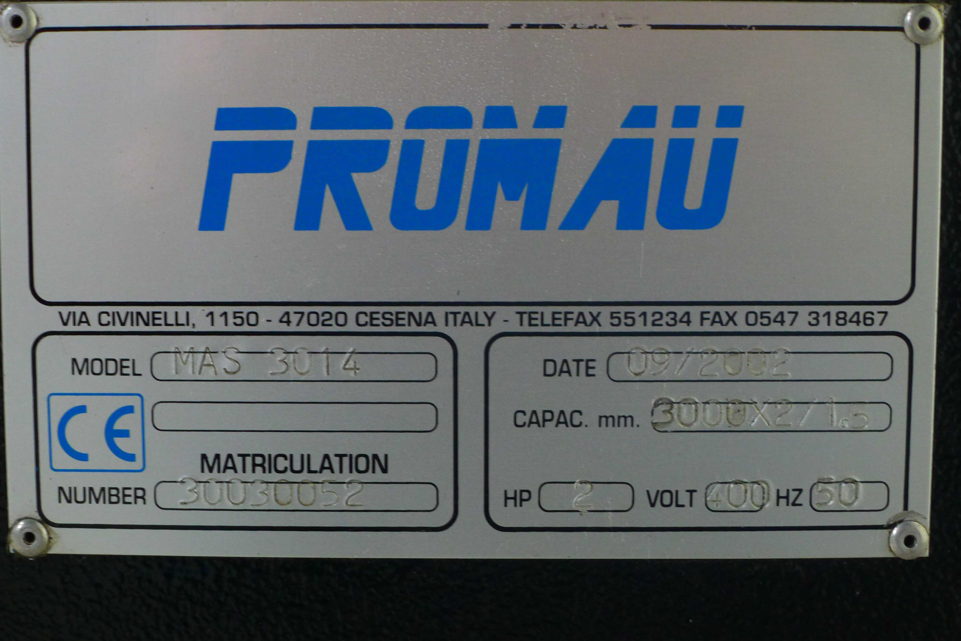
- Hydraulic Machine

ou to check any vital details!

